**CYCLE-1**

**1.Define a class ‘product’ with data members pcode, pname and price. Create 3 objects of the class and find the product having the lowest price.**

**CODE:**

public class product

{

int pcode;

int price;

String pname;

void getdata(int p1,String p2,int p3)

{

pcode=p1;

pname=p2;

price=p3;

}

public static void main(String[] args)

{

System.out.println("Name : Anna Jose");

System.out.println("Register Number : SJC22MCA-2008");

System.out.println("Course Name : Object Oriented Programming Lab");

System.out.println("Course Code : 20MCA132");

System.out.println("Date : 24/03/2023");

int smallest;

product obj1 = new product();

product obj2 = new product();

product obj3 = new product();

obj1.getdata(1111,"Refrigerator",200000);

obj2.getdata(1112,"Washing Machine",50000);

obj3.getdata(1113,"Television",150000);

if(obj1.price<obj2.price)

{

if(obj3.price<obj1.price)

{

smallest=obj3.price;

}

else

{

smallest=obj1.price;

}

}

else

{

if(obj2.price<obj3.price)

{

smallest=obj2.price;

}

else

{

smallest=obj3.price;

}

}

System.out.println("The cheapest price is : "+smallest);

}

}

**OUTPUT:**

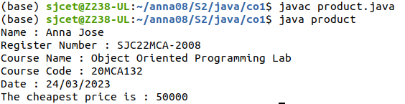

**2.Read 2 matrices from the console and perform matrix addition.**

**CODE:**

import java.util.*;

public class Matrix

{

public static void main(String[] args)

{

System.out.println("Name : Anna Jose");

System.out.println("Register Number : SJC22MCA-2008");

System.out.println("Course Name : Object Oriented Programming Lab");

System.out.println("Course Code : 20MCA132");

System.out.println("Date : 24/03/2023");

int r,c;

Scanner x = new Scanner (System.in);

System.out.println("Number of rows");

r=x.nextInt();

System.out.println("Number of coloumn");

c=x.nextInt();

int m1[][]=new int[r][c];

int m2[][]=new int[r][c];

int m3[][] = new int[r][c];

System.out.println("Enter all the elements of first matrix:");

for (int i = 0; i < r; i++)

{

for (int j = 0; j < c; j++)

{

m1[i][j] = x.nextInt();

}

}

System.out.println("");

System.out.println("Enter all the elements of second matrix:");

for (int i = 0; i < r; i++)

{

for (int j = 0; j < c; j++)

{

m2[i][j] = x.nextInt();

}

}

System.out.println("");

System.out.println("First Matrix:");

for (int i = 0; i < r; i++)

{

for (int j = 0; j < c; j++)

{

System.out.print(m1[i][j]+" ");

}

System.out.println("");

}

System.out.println("Second Matrix:");

for (int i = 0; i < r; i++)

{

for (int j = 0; j < c; j++)

{

System.out.print(m2[i][j]+" ");

}

System.out.println("");

}

for (int i = 0; i < r; i++)

{

for (int j = 0; j < c; j++)

{

for (int k = 0; k < c; k++)

{

m3[i][j] = m1[i][j] + m2[i][j];

}

}

}

System.out.println("Matrix after addition:");

for (int i = 0; i < r; i++)

{

for (int j = 0; j < c; j++)

{

System.out.print(m3[i][j]+" ");

}

System.out.println("");

}

}

}

**OUTPUT:**

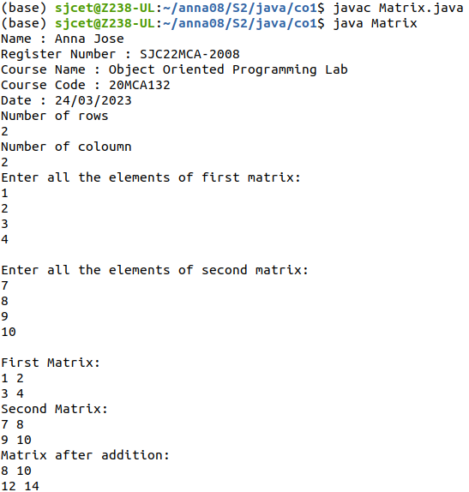

**3.Add complex numbers.**

**CODE:**

class ComplexNumber

{

int real, image;

public ComplexNumber(int r, int i)

{

this.real = r;

this.image = i;

}

public void showC()

{

System.out.print(this.real + " +i" + this.image);

}

public static ComplexNumber add(ComplexNumber n1,

ComplexNumber n2)

{

ComplexNumber res = new ComplexNumber(0, 0);

res.real = n1.real + n2.real;

res.image = n1.image + n2.image;

return res;

}

public static void main(String arg[])

{

System.out.println("Name : Anna Jose");

System.out.println("Register Number : SJC22MCA-2008");

System.out.println("Course Name : Object Oriented Programming Lab");

System.out.println("Course Code : 20MCA132");

System.out.println("Date : 28/03/2023");

ComplexNumber c1 = new ComplexNumber(4, 5);

ComplexNumber c2 = new ComplexNumber(10, 5);

System.out.print("first Complex number: ");

c1.showC();

System.out.print("\nSecond Complex number: ");

c2.showC();

ComplexNumber res = add(c1, c2);

System.out.println("\nAddition is :");

res.showC();

}

}

**OUTPUT:**

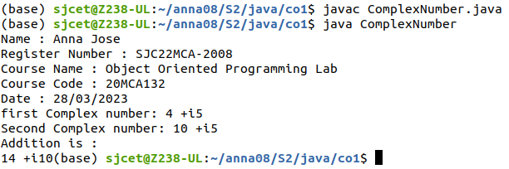

**4.Read a matrix from the console and check whether it is symmetric or not.**

**CODE:**

import java.util.*;

class symmetric

{

public static void main(String args[])

{

System.out.println("Name : Anna Jose");

System.out.println("Register Number : SJC22MCA-2008");

System.out.println("Course Name : Object Oriented Programming Lab");

System.out.println("Course Code : 20MCA132");

System.out.println("Date : 28/03/2023");

Scanner sc = new Scanner(System.in);

int i,j,r,c,flag=1;

System.out.println("Enter the number of rows:");

r = sc.nextInt();

System.out.println("Enter the number of columns:");

c = sc.nextInt();

int[][] m = new int[r][c];

int [][] transpose = new int[r][c];

System.out.println("Enter the elements of the matrix") ;

for(i=0;i<r;i++)

{

for(j=0;j<c;j++)

{

m[i][j] = sc.nextInt();

}

}

System.out.println("The elements of the matrix") ;

for(i=0;i<r;i++)

{

for(j=0;j<c;j++)

{

System.out.print(m[i][j]+"\t");

}

System.out.println("");

}

for(i=0;i<r;i++)

{

for(j=0;j<c;j++)

{

transpose[j][i]=m[i][j];

}

}

if(r==c)

{

for(i=0;i<r;i++)

{

for(j=0;j<c;j++)

{

if(m[i][j]!=transpose[i][j])

{

flag=0;

break;

}

}

if(flag==0)

{

System.out.print("\nThe matrix is not symmetric");

break;

}

}

if(flag==1)

{

System.out.print("\nThe matrix is symmetric\n");

}

}

else

{

System.out.print("\nThe matrix is not symmetric\n");

}

}

}

**OUTPUT:**

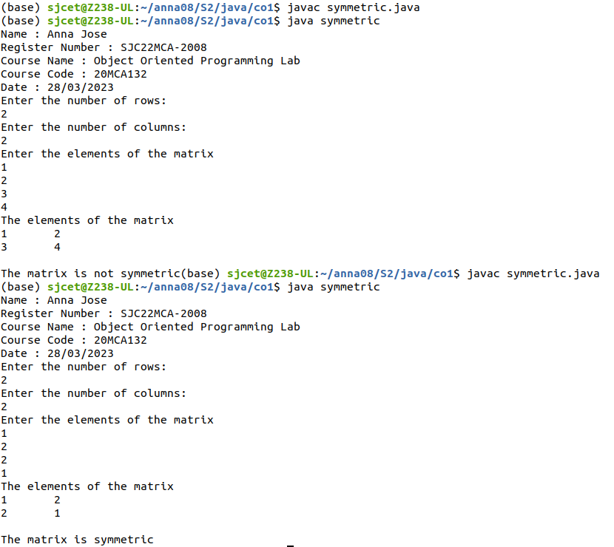

**5.Create CPU with attribute price. Create inner class Processor (no. of cores,manufacturer) and static nested class RAM (memory, manufacturer). Create an object of CPU and print information of Processor and RAM.**

**CODE:**

public class cpu{

int price;

class processor{

int cores;

String producer;

processor(int noC, String manu){

cores=noC;

producer=manu;

}

void display(){

System.out.println("\nProcessor info");

System.out.println("No. of Cores = "+cores);

System.out.println("Manufacturer = "+producer+"\n");

}

}

static class ram{

int mem;

String manuf;

ram(int memory,String producer ){

mem=memory;

manuf=producer;

}

void display(){

System.out.println("\nRAM info");

System.out.println("Memory = "+mem+" GB");

System.out.println("Manufacturer = "+manuf+"\n");

}}

public static void main(String[] args) {

System.out.println("Name : Anna Jose");

System.out.println("Register Number : SJC22MCA-2008");

System.out.println("Course Name : Object Oriented Programming Lab");

System.out.println("Course Code : 20MCA132");

System.out.println("Date : 28/03/2023");

cpu.ram obj1= new cpu.ram(8,"Intel");

cpu obj2 = new cpu();

cpu.processor obj3 = obj2.new processor(8,"Samsung");

obj1.display();

obj3.display();

}

}

**OUTPUT:**

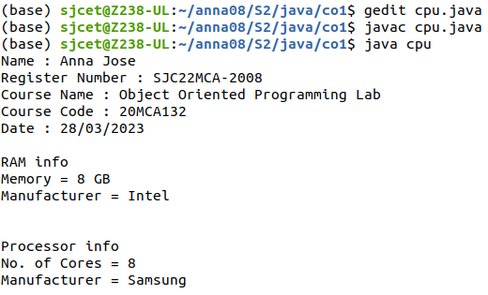

**CYCLE-2**

**1.Program to Sort strings.**

**CODE:**

import java.util.Arrays;

import java.util.Scanner;

public class sortuserstrings {

public static void main(String[] args) {

Scanner input = new Scanner(System.in);

System.out.println("Name : Anna Jose");

System.out.println("Register Number : SJC22MCA-2008");

System.out.println("Course Name : Object Oriented Programming Lab");

System.out.println("Course Code : 20MCA132");

System.out.println("Date : 04/04/2023");

System.out.print("Enter the number of strings you want to sort: ");

int n = input.nextInt();

String[] names = new String[n];

System.out.println("Enter the strings to be sorted:");

for (int i = 0; i < n; i++) {

names[i] = input.next();

}

Arrays.sort(names);

System.out.println("Sorted Names: ");

for (String name : names) {

System.out.println(name);

}

}

}

**OUTPUT:**

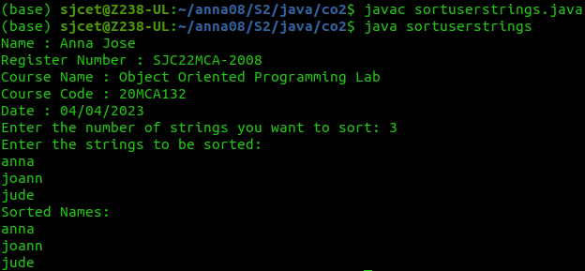

**2.Search an element in an array.**

**CODE:**

import java.util.*;

class Array

{

public static void main(String args[])

{

System.out.println("Name : Anna Jose");

System.out.println("Register Number : SJC22MCA-2008");

System.out.println("Course Name : Object Oriented Programming Lab");

System.out.println("Course Code : 20MCA132");

System.out.println("Date : 04/04/2023");

Scanner sc=new Scanner(System.in);

int i,n,s,flag=0;

System.out.println("enter the number of elements :");

n=sc.nextInt();

int [] a=new int[n];

System.out.println("enter the elements");

for(i=0;i<n;i++)

{

a[i]=sc.nextInt();

}

System.out.println("enter the element to be searched:");

s=sc.nextInt();

for(i=0;i<n;i++)

{

if(a[i]==s)

{

System.out.println("Element " + s + "found at "+ i + " position");

flag=1;

break;

}

}

if(flag==0)

{

System.out.println("Element not found");

}

}

}

**OUTPUT:**

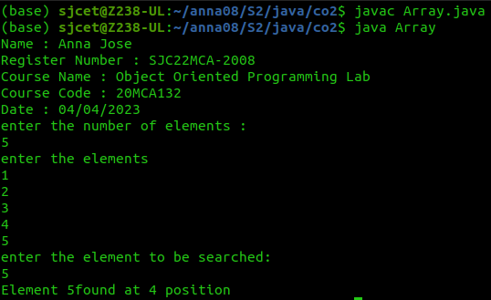

**3.Perform string manipulations .**

**CODE:**

import java.util.Scanner;

public class String_man{

public static void main(String[] args) {

System.out.println("Name : Anna Jose");

System.out.println("Register Number : SJC22MCA-2008");

System.out.println("Course Name : Object Oriented Programming Lab");

System.out.println("Course Code : 20MCA132");

System.out.println("Date : 29/04/2023");

System.out.println("Enter The String");

Scanner sc = new Scanner(System.in);

String str1 = sc.nextLine();

System.out.println("Length of String = "+str1.length());

System.out.println("Character at First position = "+str1.charAt(1));

System.out.println("String Contains 'Col' sequence :"+str1.contains("Col"));

System.out.println("String ends with e : "+str1.endsWith("e"));

System.out.println("Replace'col' with 'kol' : "+str1.replaceAll("Col","kol"));

System.out.println("LOWERCASE : "+str1.toLowerCase());

System.out.println("UPPERCASE : "+str1.toUpperCase());

}

}

**OUTPUT:**

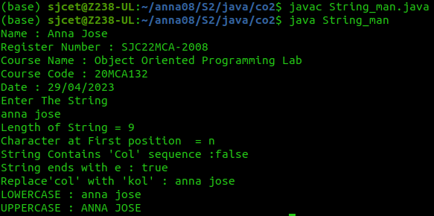

**4.Program to create a class for Employee having attributes eNo, eName eSalary. Read n**

**employ information and Search for an employee given eNo, using the concept of Array of**

**Objects.**

**CODE:**

import java.util.Scanner;

public class employee {

int eNo;

String eName;

double eSalary;

public void getdetails(){

System.out.println("\nEnter the Employee details");

Scanner sc = new Scanner(System.in);

System.out.println("Employee number : ");

eNo=sc.nextInt();

System.out.println("Name : ");

sc.nextLine();

eName=sc.nextLine();

System.out.println("Salary : ");

eSalary=sc.nextDouble();

}

void display(){

System.out.println("Empolyee No :"+eNo);

System.out.println("Name :"+eName);

System.out.println("Salary Amount"+eSalary+"\n");

}

public static void main(String[] args) {

System.out.println("Name : Anna Jose");

System.out.println("Register Number : SJC22MCA-2008");

System.out.println("Course Name : Object Oriented Programming Lab");

System.out.println("Course Code : 20MCA132");

System.out.println("Date : 04/04/2023");

System.out.println("\nEnter the No. of Employee's");

Scanner sc1 = new Scanner(System.in);

int num = sc1.nextInt();

employee arr[]=new employee[num];

for(int i =0;i<num;i++){

arr[i]=new employee();

arr[i].getdetails();

}

System.out.println("\nInformations of all the employee's");

for(int i=0;i<num;i++){

arr[i].display();

}

boolean state = false;

System.out.println("\nEnter the Employee Number to get details of a employee");

int num2= sc1.nextInt();

for(int i=0;i<num;i++){

if(arr[i].eNo==num2){

System.out.println("\nEmployee details");

arr[i].display();

}

}

}

}

**OUTPUT:**

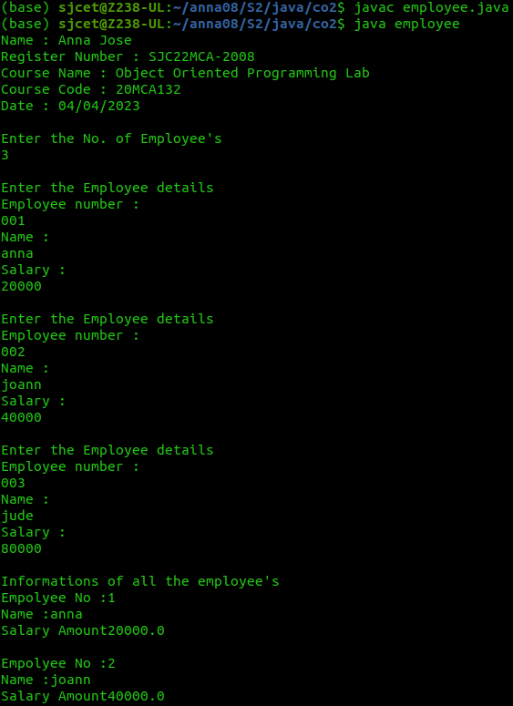

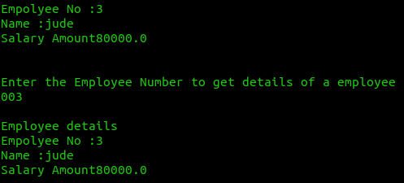

**CYCLE-3**